**SVKM’S NMIMS**

**MUKESH PATEL SCHOOL OF TECHNOLOGY MANAGEMENT& ENGINEERING**

**(Campus Name)**

Academic Year: 2022-2023

**Practical 5 –Program to demonstrate synchronization through Producer/Consumer problem.**

|  |  |  |
| --- | --- | --- |
| Name:Arjun Mehta | Roll_No:K036 | SAP-ID:70102300018 |
|  |  |  |

Dear all,

Kindly complete the following task with your name in output file also attach the C/Java program with the file.

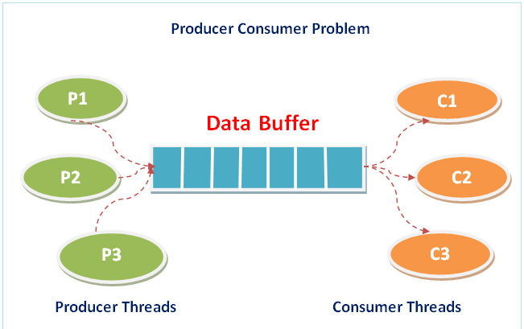

## **Code:**

#!/usr/bin/env python

# coding: utf-8

# In[7]:

import threading

# In[8]:

# Initialize a mutex to 1

mutex = threading.Lock()

# Number of full slots as 0

full = 0

# Number of empty slots as size of buffer

empty = 10

x = 0

# In[9]:

# Function to produce an item and add it to the buffer

def producer():

global full, empty, x

with mutex:

# Increase the number of full slots by 1

full += 1

# Decrease the number of empty slots by 1

empty -= 1

# Item produced

x += 1

print(f"\nProducer produces item {x}")

# In[10]:

# Function to consume an item and remove it from buffer

def consumer():

global full, empty, x

with mutex:

# Decrease the number of full slots by 1

full -= 1

# Increase the number of empty slots by 1

empty += 1

print(f"\nConsumer consumes item {x}")

x -= 1

# In[11]:

# Driver Code

def main():

while True:

print("\n1. Press 1 for Producer"

"\n2. Press 2 for Consumer"

"\n3. Press 3 for Exit")

n = int(input("\nEnter your choice: "))

# Switch Cases

if n == 1:

# If mutex is available and empty is non-zero, then it is possible to produce

if mutex.locked() == False and empty != 0:

producer()

else:

print("Buffer is full!")

elif n == 2:

# If mutex is available and full is non-zero, then it is possible to consume

if mutex.locked() == False and full != 0:

consumer()

else:

print("Buffer is empty!")

elif n == 3:

break

# In[12]:

if __name__ == "__main__":

main()

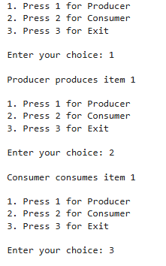

OUTPUT:

## **Conclusion: -**

Write your observation about Producer- consumer problem. How it is more useful in modern operating systems.

References:

studocu.com/row/document/hamdard-university/legal-system/lab-8-producer-consumer-problem/29445188

<https://www.geeksforgeeks.org/producer-consumer-problem-in-c/?ref=rp>